Date: October 24, 2018 at 4:00 pm
Location: Edith + Arthur, Fleetwood, Surrey
In attendance: Diana Brebeck, Stephen Church, Kristy Harrison, Drew Landry, Cheryl Leclerc, Selina Metcalfe, Lora Sarchet, Vanessa Sauer, Sarah Schnare, Keri Stanger, Marley Stewart, Hilary Wardlow, Johnny Zvi; Regrets: Amy Wilder
Agenda:
- Catching up (all)

- EEPSA Business

- EEPSA update (Drew): noted that we officially formed the LSA SEED 36 (Surrey Ecological Educators in District 36), a subsection of the STA and a local chapter of EEPSA; aim to have four meetings per year.

Executive members (so far): Drew Landry (President); Amy Wilder (Treasurer); Kristy Harrison (secretary). Other roles/positions on the executive are welcomed (e.g. membership co-ordinator, pro-d chairperson etc.)
.
- Financials update (Drew for Amy): current total: $560
Members of Seed36 are encouraged to join or renew their $30 membership to EEPSA as our funding allotment is based on membership; Pro-D funding can be used for PSA memberships. Links:
http://eepsa.org/membership/
https://bctf.ca/psa/join.aspx
https://bctf.ca/uploadedFiles/Public/PSAs/~PSA-ApplicationForm.pdf
https://www.surreyteachers.org/wp-content/uploads/2018/07/Individual-ProD-Application.pdf

- Previous Business: discussed our mandate, with examples.

The goals of SEED 36 are:
1) Assist in developing policies for natural play spaces, outdoor gardens, and environmental education (advocacy of teacher/student needs.)
- current SEED 36 members were part of a working group to develop process and policy for the school garden resource
- advocating for permission form policies for elementary and secondary teachers to take students outside
- Relationship building with Surrey Parks and community partners to support use of outdoor spaces and accessing place-based educational opportunities.
- navigating the Surrey Parks programmes: SHaRP, Friends of the Forest, Park Stewards, Take the Dip, Releaf, Surrey Youth Stewardship Squad
- community partners: Friends of Semiahmoo Bay Society; Honeybee Centre; A Rocha Canada Brooksdale Environmental Centre; Little Campbell Hatchery; Lower Mainland Green Team
3) Support Professional Development, networking, and resource sharing in SD36.
- supporting schools with their environmental education focused Pro-D goals
- promoting the Classrooms to Communities Watershed STA Day excursion
- developing SEED 36 website(?) for sharing resources, events, programs

- Upcoming Business: discussed the new Surrey Schools School Garden Resource.
Memo from District: In response to a growing interest in school gardens, we are pleased to release a Surrey Schools School Garden Resource and School Garden Application process. Over the past year a collaborative Working Group came together to share their experience with school gardens and to assess what has worked and what hasn’t. Their experience, along with the experiences of other school districts and expertise of community partners and gardening organizations, was used to build our Surrey Schools approach to school gardens.
In order to ensure that school gardens are developed in an intentional way that allows the district to learn as we grow, a maximum of 10 school gardens will be approved this school year. Schools requesting a garden will be part of a pilot process and will be required to provide feedback on both the Resource and the application process. Should there be more than 10 applicants this year, those who have successfully completed an application will be selected using a lottery. Priority will be given to a distribution of gardens across district zones.
- Application due date: December 1, 5pm
- District approval will be based on commitment, succession, quality and readiness of application, location within district; 10 schools will be chosen this year
- Funding ideas: PAC, Business Development funds ($1000), Farm-to-School grant (4 X $3000), TD Friends of Environment, Stewards of the Future, other community grants
- Drew recommends applying early for consideration for the Farm-to-School grant; contact him for feedback on your application/more info about the grant
- Ideas for location: put garden in sunniest location, near an outside water source (look for a metal plate at the base of school); locations will be decided in consultation with Grounds Department
- Engage other programmes in your school (e.g. BASES, life skills, cafeteria, aboriginal teacher, Environment/Garden student clubs, at-risk programs)
- Contract Drew for more information on funding, his powerpoint on North Surrey’s process and contacts for plants, seeds, equipment (e.g. West Coast Seeds, Harvest Power)
- Note: existing school gardens will be grandfathered and do not need to reapply to be 1 of the 10 gardens this year; however, if they want to expand they will need to follow the new policies

- Celebrating outdoor learning spaces in SD 36!
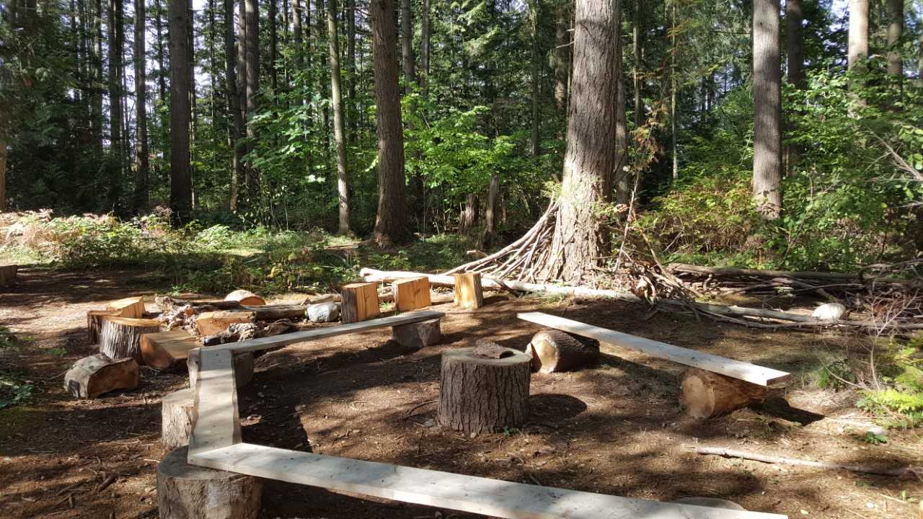

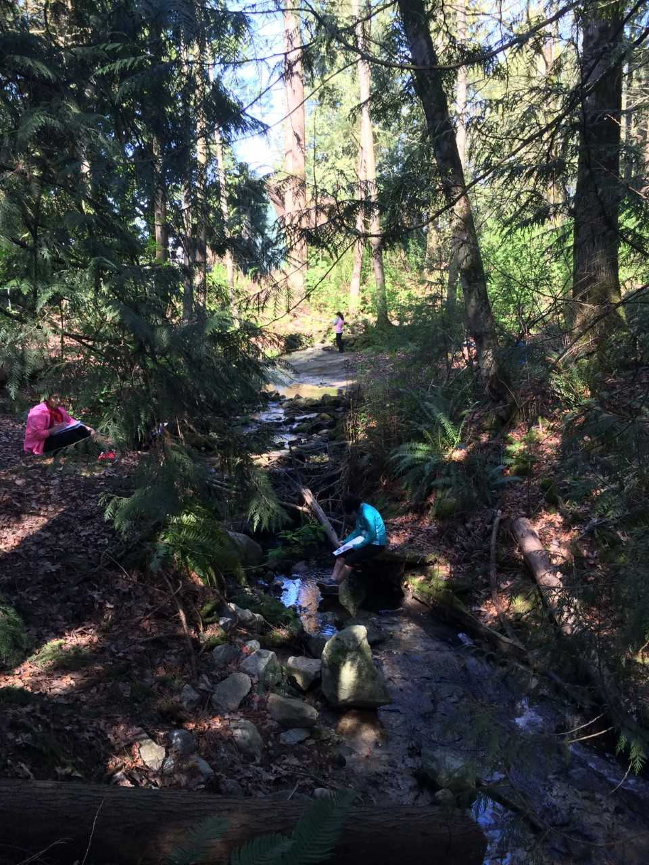

Cambridge Elementary outdoor learning.
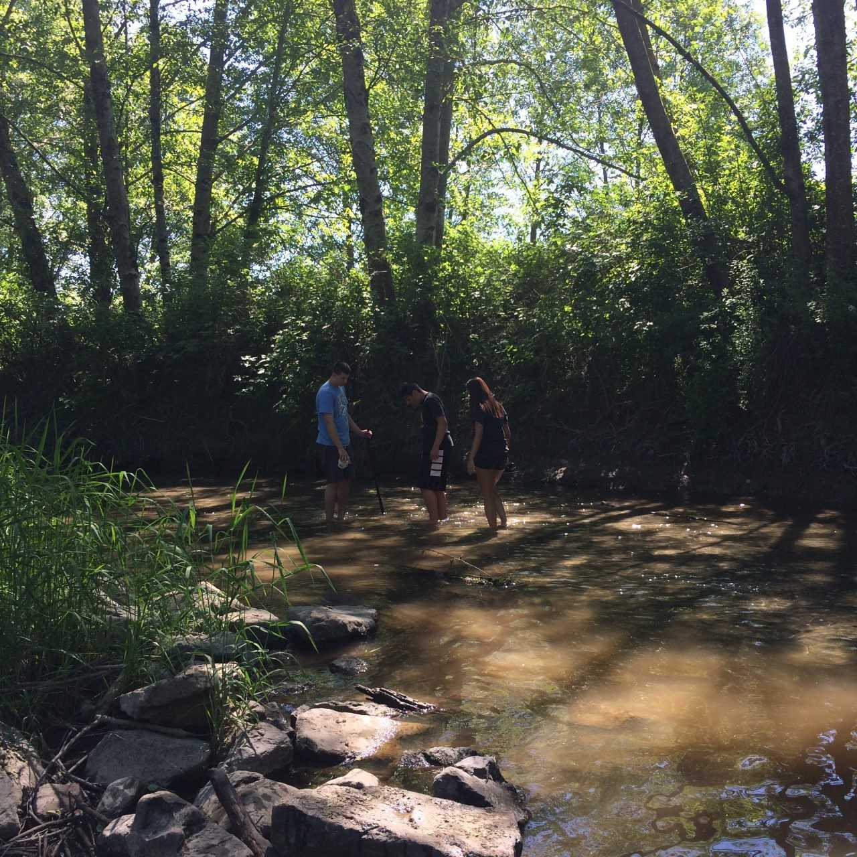

Fleetwood Park students at Fleetwook Park. Fleetwood Park students at Surrey Lake.

If you would like to share photos of your outdoor learning space, please email pics with location and a brief description to Kristy Harrison harrison_kristy@surreyschools.ca to be included in a Gallery of Outdoor Learning Spaces. (location TBD)

- Next meeting: Tuesday, December 11 at East Kensington Elementary (2795 184th St.)
Meet at 3:45 pm for a guided walk of EKOLogy programme; 4:00 pm SEED36 meeting

Meeting adjourned: 6 pm

