**Date**: December 11, 2018 at 4:00 pm

**Location**: East Kensington Elementary

**In attendance**: Diana Brebeck, Stephen Church, Chantelle DesLauriers, Bree Greve, Kristy Harrison, Drew Landry, Cheryl Leclerc, Keri Stanger, Christine Syms, Amy Wilder **Regrets**: Selina Metcalfe, Johnny Zvi

**Agenda**:

1. Catching up (all)
2. Tour of East Kensington Outdoor Learning (EKOLogy) with Cheryl and Keri

Our guided tour of EKOLogy included a visit to their gated wetland, outdoor “Big Loose Parts” play area, picnic site, future pergola site and Grade 1 classroom. Hope is for future safe access to the creek and/or forested area behind the school. This programme of choice has grown to three classes from K-4 and next year will expand to include Grade 5. Students spend 2 hours every morning exploring outdoor learning experiences in all weather conditions. Teachers use inquiry and student questions to guide their outdoor studies; for example: finding a dead duck lead to discussion about food cycles, decomposition and investigating teeth of predators to infer prey. Opportunities for students to identify and navigate risk are given through supervised use of the “Big Loose Parts” playground and forest play in nearby Redwood Park.

Cheryl noted: “We are in year 2 of the Wild Schools program and have utilized these resources from them in our planning: Get Outdoors (free PDF available online) and Growing Up Wild from Project Wild.”

<https://www.surreyschools.ca/NewsEvents/Posts/Lists/Posts/Post.aspx?ID=654>

1. EEPSA Business

**EEPSA update (Drew):** Members of Seed36 are encouraged to join or renew their $30 membership to EEPSA as our funding allotment is based on membership; Pro-D funding can be used for PSA memberships. Links:

<http://eepsa.org/membership/> <https://bctf.ca/psa/join.aspx>

<https://bctf.ca/uploadedFiles/Public/PSAs/~PSA-ApplicationForm.pdf>

**Financials update (Amy):** current total: $_______

1. **Previous Business**: discussed the School Garden Resource and application process.

Update: 17 applications were received for a variety of garden projects including food, native plants, and gardens to attract pollinators. 10 schools will be selected this year, hopefully by January. Drew suggested if your site is not chosen to continue to build programs at your school (e.g. Garden clubs, build interest though activities such as “Spuds in Tubs” or “Living on the Ledge” windowsill potato projects in the classrooms) and reapply next year.

Feedback on the application process:

* The application package was helpful, comprehensive and informative as a resource for what is involved in the planning and implementation of school gardens.
* Would be helpful if they confirmed receipt of the application once it was submitted.
* The timeline of the application process is appropriate/could be earlier to help implementation, applications to secure PAC funding, fundraising efforts, etc.
* Some found budgeting challenging as they weren’t sure if the district is planning on bulk-buying and if the district is helping with any aspects of the costs for implementation once approved. It was suggested that a resource or catalog for purchasing costs/orders would be helpful for crafting a budget.
* Access to water may be challenging for some sites. It was suggested that the policy reconsider the use of rain barrels to help with watering.

1. **Upcoming Business**:
2. Brainstorming discussion for ideas for Pro-D.

Our funding can be used to offer Pro-D for teachers or to help schools run their own environmental ed pro-d. We brainstormed the following and will revisit at our next meeting:

* Offering a Pro-D event on the district focus day
* Offering a booth/session/activities at the STA Day elementary and secondary conventions (e.g. Find Nature in your School Ground, help with what to do for outdoor learning, how to make curricular connections)
* Offering a booth/session/”walkshop”/activity at the Classrooms to Communities excursion site on the STA Day
* Offering other off-site excursion on the STA Day (e.g. EKOLogy for Elementary; North Surrey Garden for Secondary - Drew and Stephen could do a Garden Pro-D)
* Developing a “Garden Activity Guide” and showing teachers how to take kids outside
* Keri has connections to individuals in her Master’s program who are integrating environmental education across several subjects at the secondary level (e.g. Science/Math/English/outdoor PE)

1. Park Stewards School Program with Urban Forestry, City of Surrey

Bree Greve and Chantelle DesLauriers from the City of Surrey were at the meeting to network and to talk about the consolidation of elementary and secondary school programs under the umbrella of Park Stewards. This will include Releaf Tree Planting, Invasive Removal (previously called Forest Stewards) and other environmental education in schools. If teachers are looking to connect with their local park or engage in stewardship programs, contact Bree and Chantelle at [stewardship@surrey.ca](mailto:stewardship@surrey.ca)

More info: <https://www.surrey.ca/culture-recreation/27711.aspx>

1. Celebrating outdoor learning spaces in SD 36! Photo credit: Laura Johnston (first row) and Cheryl Leclerc (second row).

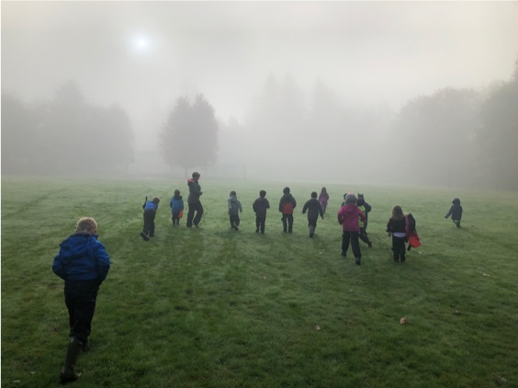

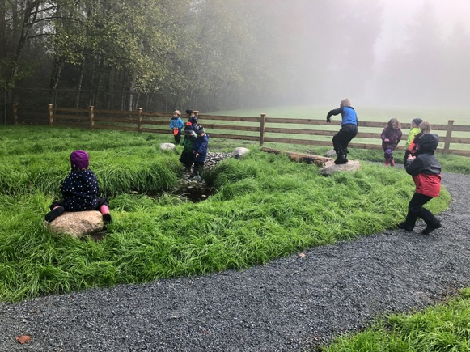

Wetland at East Kensington Elementary. Foggy walk in soggy fields at EKOLogy.

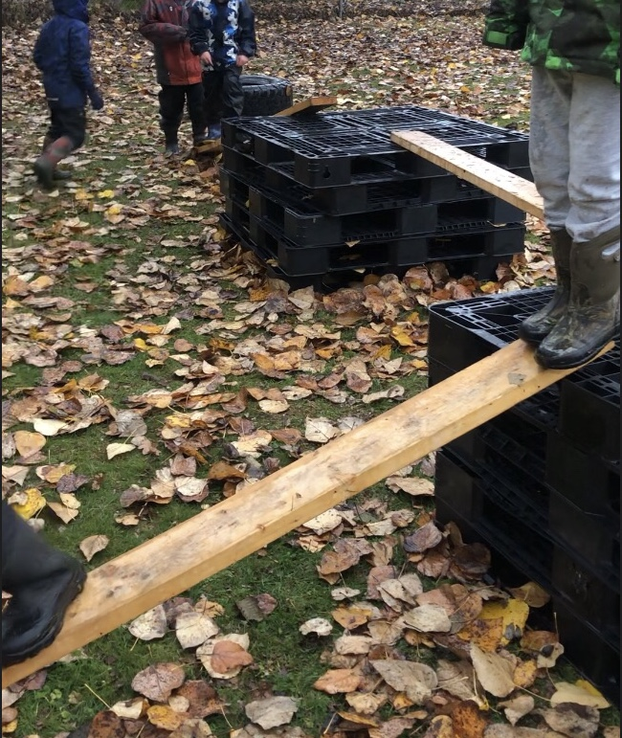

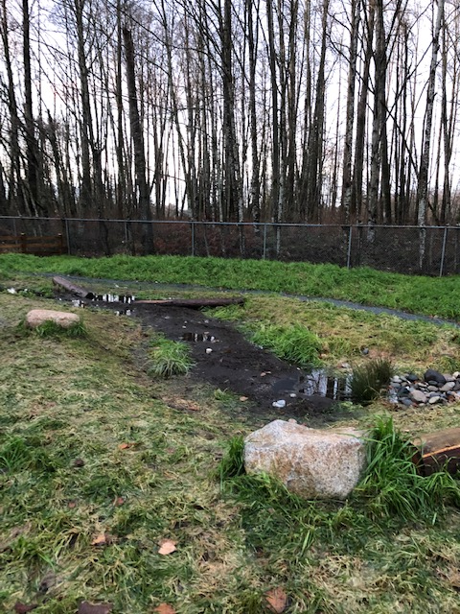



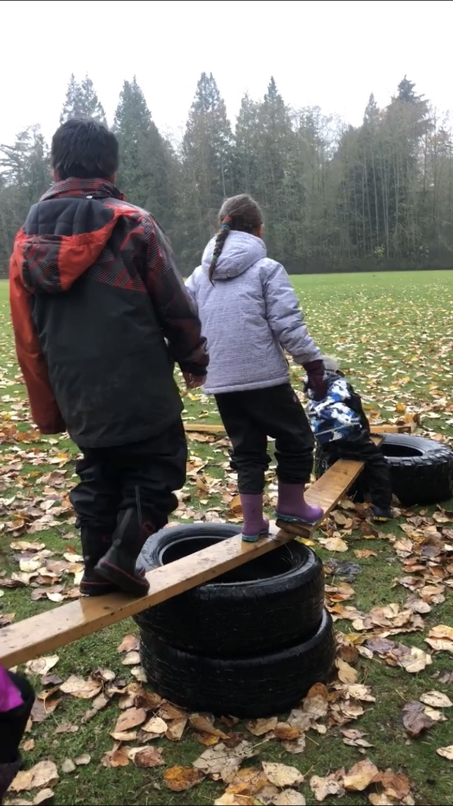

Wetland. “Big Loose Parts” playground.

If you would like to share photos of your outdoor learning space, please email pics with location and a brief description to Kristy Harrison [harrison_kristy@surreyschools.ca](mailto:harrison_kristy@surreyschools.ca) to be included in a Gallery of Outdoor Learning Spaces. (location TBD)

1. **Next meeting**: TBA (Likely a Tuesday in late Feb/March) Thanks to Keri, Cheryl and EKOLogy for the tour, goodies and hosting our meeting.

Meeting adjourned: 5 pm