Date: March 6 at 4:00 pm
Location: North Surrey Secondary
In attendance: Bree Greve, Kristy Harrison, Drew Landry, Cheryl Leclerc, Selina Metcalfe Keri Stanger, Sarah Schnare, Christine Syms
Agenda:
- Catching up (all) – discussed which of the schools present at the meeting had been chosen for one of the 10 garden sites

- EEPSA Business

EEPSA update (Drew): Members of Seed36 are encouraged to join or renew their $30 membership to EEPSA as our funding allotment is based on membership; Pro-D funding can be used for PSA memberships. Links:
http://eepsa.org/membership/ https://bctf.ca/psa/join.aspx
https://bctf.ca/uploadedFiles/Public/PSAs/~PSA-ApplicationForm.pdf

Financials update (Amy): current total: $_______

- Previous Business: planning session for the STA Pro-D Day.

Tentative Shape of the Day (times and details subject to approval and tweaking) – Selina will submit proposal to STA; Sarah will create a flyer to advertise day to SEED36 and other SD36 networks
AM: Exploring Outdoor Learning Spaces at EKOlogy - East Kensington (9:00 – 11:00)
- Map activity: Where we are on Surrey Map (Selina)
- Sharing session for using and creating outdoor learning spaces and sharing resources for what to do outside with students (Keri, Cheryl, Alison, Christine will help with finding facilitators / facilitating)
- Aims for sharing session: what are teachers and students already doing at the various sites; what are some ideas and resources for ecological education; curricular links
Lunch & AGM: North Surrey (11:30 – 12:30)
- Tour and lunch harvest from the garden at North Surrey, supplemented with locally sourced foods (e.g. local produce, bakery, honeybee centre) – discussed ideas for funding lunch: STA, SEED36, City of Surrey? (Drew will organize; Kristy can pick up food)
- Join us for AGM meeting for SEED36 – aim to elect more members for executive positions for next year (Selina will chair; VP will chair next year)
PM Site 1: North Surrey (12:30 – 2:30): Creating a Garden Space (Elementary/ Secondary)
- Drew will share his powerpoint about the process of creating the garden at North Surrey; go over the steps and tips for building a garden space
- Answer questions for teachers whose applications were approved this year
- Discuss the application process and District Garden Resource for groups planning to reapply or submit a new application next year
PM Site 2: Godwin Park (1:00 – 3:00): Using your local City of Surrey park (Elementary)
- Bree will lead a session on how to use local parks (what to do with students and appropriate use of outdoor spaces)
- Will look into using Cosmos to print maps of schools of attendants with local parks

- Upcoming Business: Discussed outline for AGM and long-term goals for SEED 36.
- Possible positions to add to the executive to help define roles and responsibilities as we grow: Vice-President, Communications Chair; Pro-D Chair; Membership Chair; Member(s)-at-Large
- Discussed desire to provide a way to network and find out who is doing what and where (e.g. newsletter, bulletins, website/Team on Office 365?)
- Will send out Agenda of AGM to members prior to meeting
- Noted future goal would be to establish SEED36 as an LSA with the STA (right now we are a local chapter of EEPSA)
5) Celebrating outdoor learning spaces in SD 36! Photo credits: Kristy Harrison.
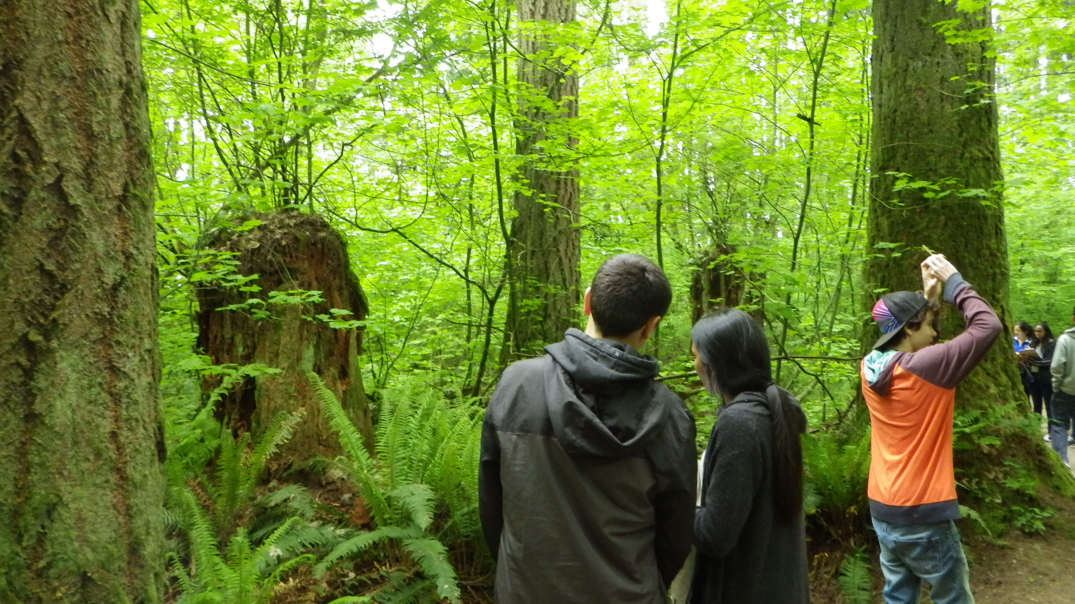
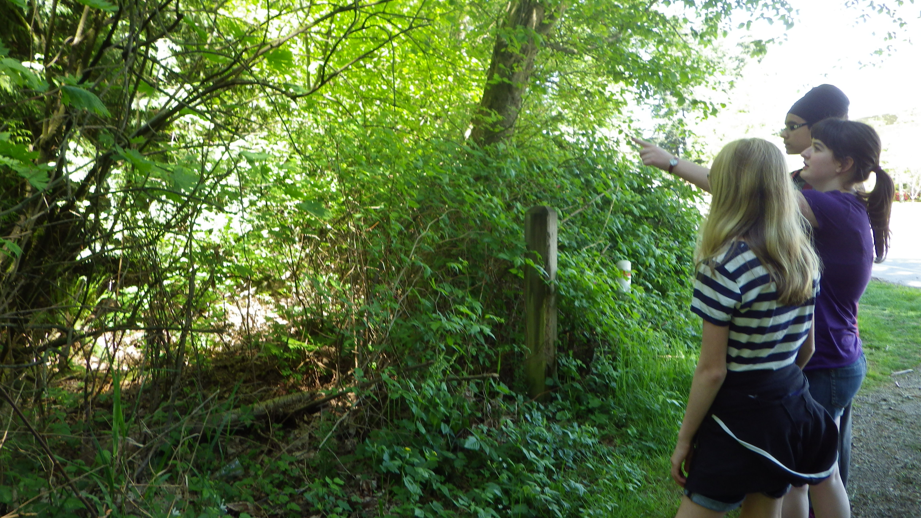

Forest Walk and Talk at Sunnyside Acres Urban Forest.
If you would like to share photos of your outdoor learning space, please email pics with location and a brief description to Kristy Harrison harrison_kristy@surreyschools.ca to be included in a Gallery of Outdoor Learning Spaces. (location TBD)

- Next meeting: AGM at North Surrey Secondary on STA Convention Day (Friday, May 3) at lunch (tentatively 11:30 am)
Meeting adjourned: 5 pm

